## horizontal line



LockedMe.com

03.02.2020

**─**

KANDREGULA SAIAJAY KUMAR

CompanyLockers Private Limited

ajay.vjit@gmail.com

# Overview

With an aim to digitize the products, here we have developed an application that performs all the basic specifications mentioned in the requirements document.

Project Follows a Scrum Methodology

Sprint Duration: 5 Business Days

Total Sprint Required: 3

# Product Capabilities, Appearance and User Interactions:

1. Application is a console based menu driven application.
2. User selects the menu options which are available from the console.
3. Retrieving the file names in the ascending order.
4. Business Level operations
5. Option to add a user specified file to the application.
6. Option to delete a user specified file from the application.
7. Option to search a user specified file from the application.
8. Navigation option to close the current execution context and return to the main context.

5. Option to close the application.

# User Stories

|  |  |
| --- | --- |
| STORY | ESTIMATION |
| Create an app for LockedMe options | 1 |
| Analyse the requirements of LockedMeApp | 1 |
| Create Add Method for File Creation | 1 |
| Create Delete Method to Delete File | 1 |
| Create a Method for Search Option | 1 |
| Create a Method to display the files in ascending order | 1 |
| Environment Setup and Sprint Demo | 1 |

## 

# Sprint Development:

The project is developed in three sprints. Here are the details mentioned regarding each sprint.

## Sprint-1

A meetup was held between the project developers and the user to listen to the stories of the user and for the time estimation to complete the project.

In the sprint-1, the project developers have to create a prototype of the project complete the Create File Method which is one of the specifications of the LockedMe.com application.

The time allotted to complete this sprint is five days, which was started on September 14 - September 18, 2020. The method was successfully created and tested.

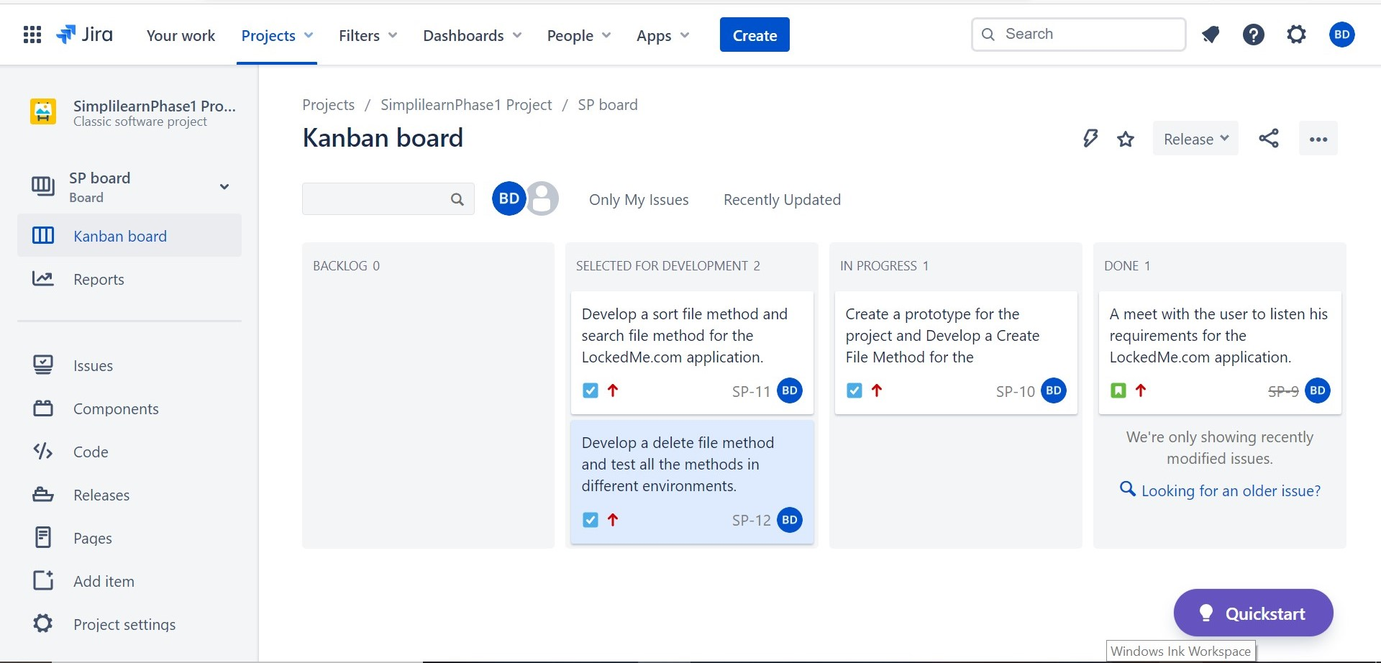

## Sprint-2

In the Sprint-2, the project developers have been given a task of creating Sort and Searching methods of the LockedMe.com application.

The time allotted to complete this Sprint is five days. The duration of the Sprint-2 is September 21-25, 2020. The methods were successfully developed and tested within the specified duration.

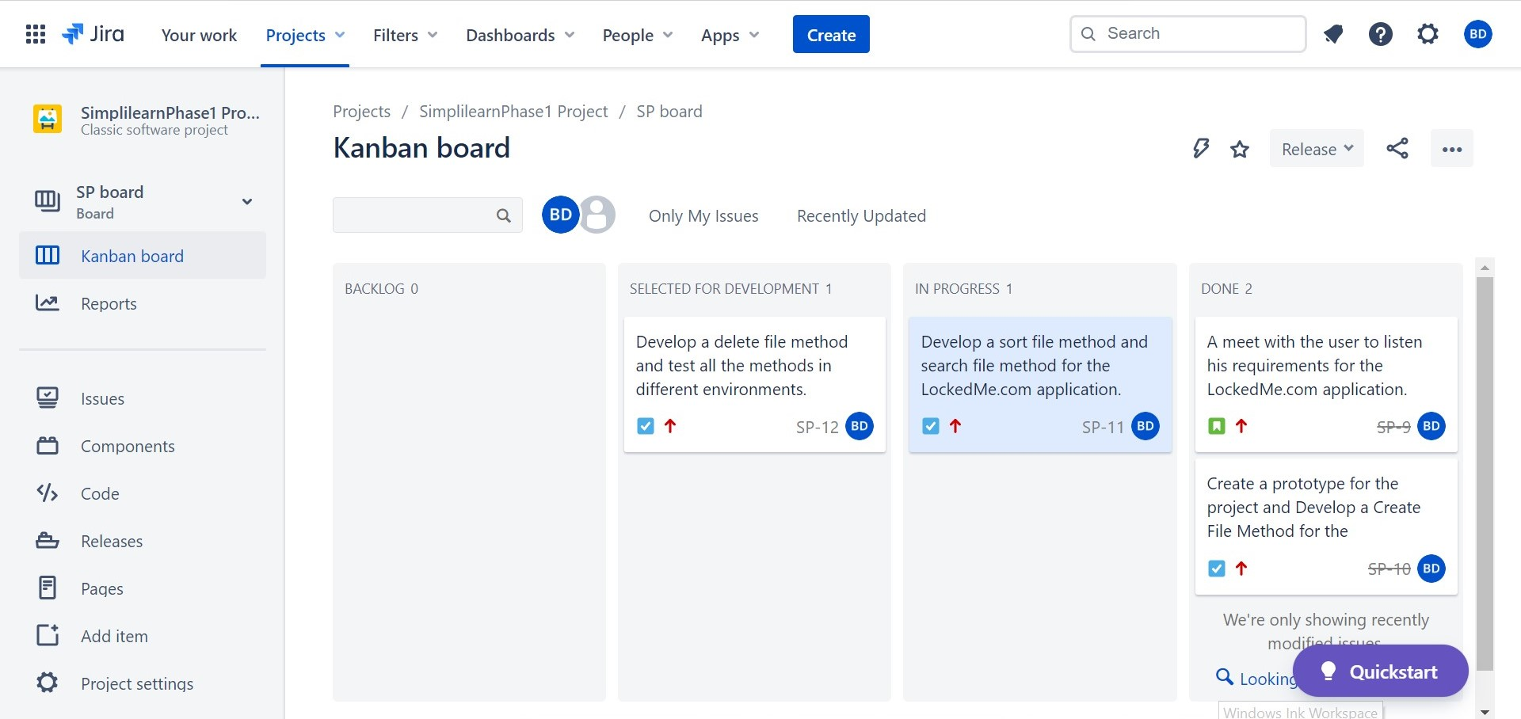

## Sprint-3

In the Sprint-3, the project developers have been given a task of creating the Delete method of the LockedMe.com application.

The time allotted to complete this Sprint is five days. The duration of the Sprint-3 is September 28 - Oct2nd, 2020. The method was successfully developed and tested within the specified duration.

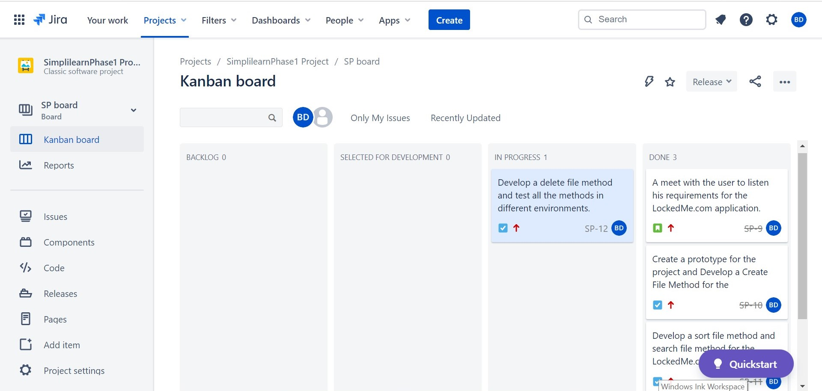

# Flow Chart:

The flow chart of the project:

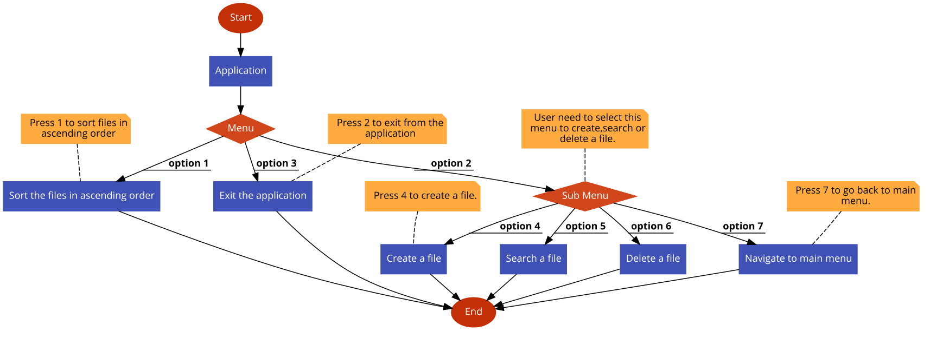

# Methods and Algorithms used in the project:

In developing this LockedMe.com project, we have used 5 methods and one sorting algorithm. They are:

1. File Details():

This method is used to get the input from the user regarding the details of the file. Here we used Scanner class to get the input from the user to specify the filename in the console.

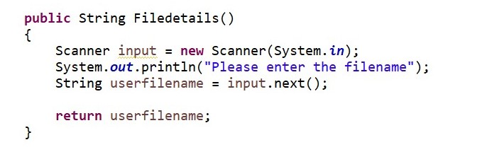

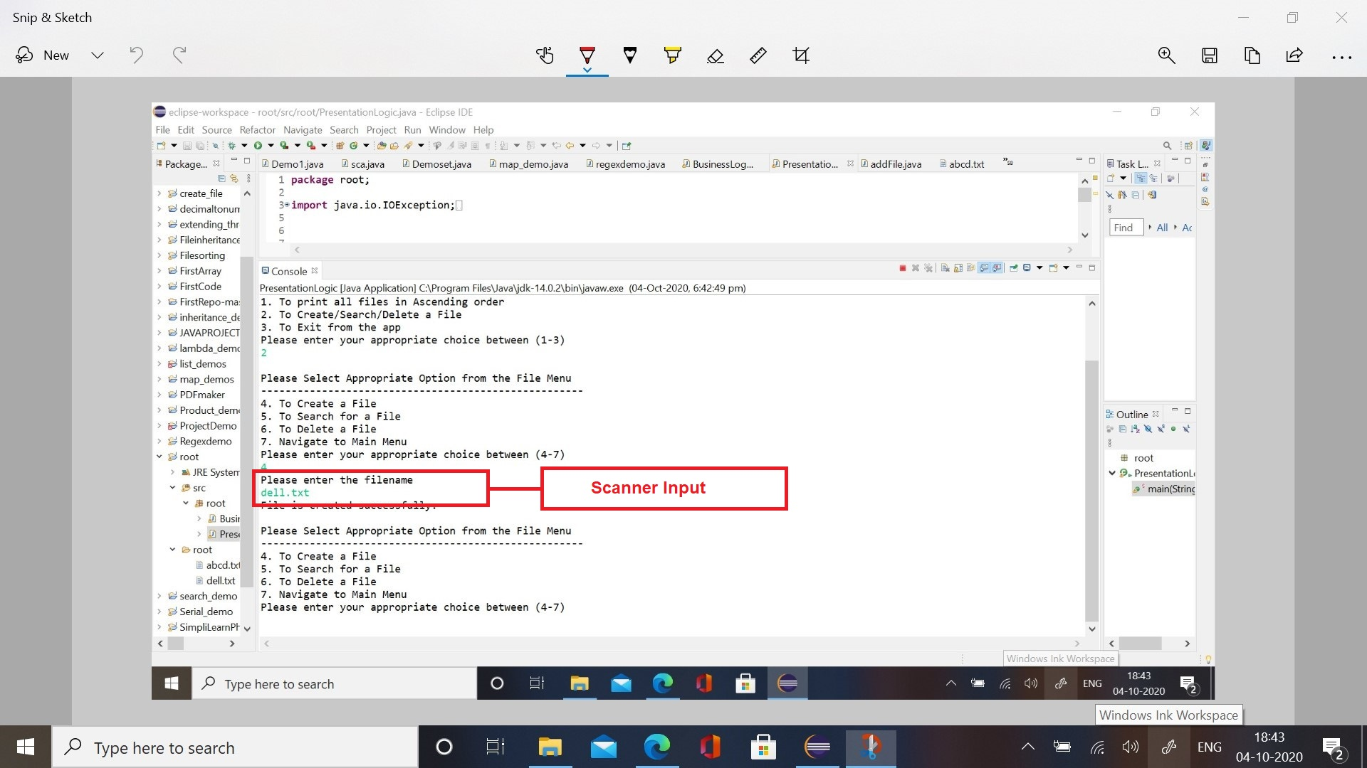

1. File Array():

This method is used to return the array of files to the different methods where the array of files is required. This method was mainly used in Sort File method, Search File Method and Delete File method.

Here we used

1. Paths.get() method to get the path of the specific directory in the system.
2. createDirectories() method to create a directory, this method will create a parent directory if it doesn't exist and does not throw any exception if the directory already exists.
3. toString() method to convert the path into string, this method is available in Object class.
4. .listFiles() method to get the files from the specific directory and save it to the files array.
5. Create File():

This method is used to create a file in a particular directory. It first checks the existence of the specified directory and later checks the existence of the file which has been entered by the user through the input method, if it exists it prints “File already exists in the directory.” or else it will create the file in the specified directory.

The methods used here are

1. Paths.get() method from the Paths class to get the path of the specific directory.
2. createDirectories() method form the Files class, this method will create a parent directory if it doesn't exist and does not throw any exception if the directory already exists.
3. Files.createFile() method to create a file.

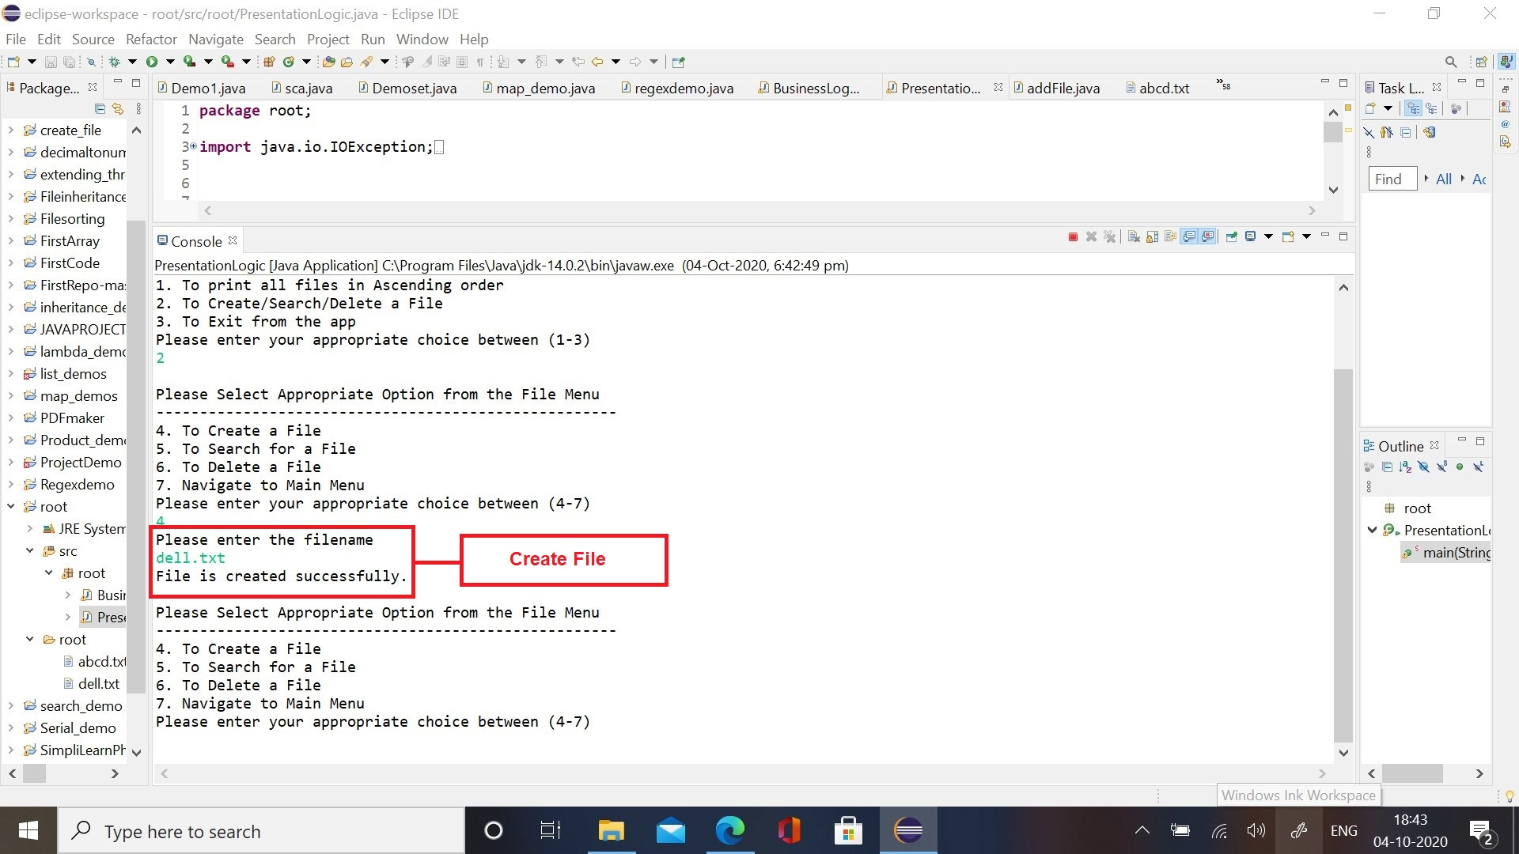

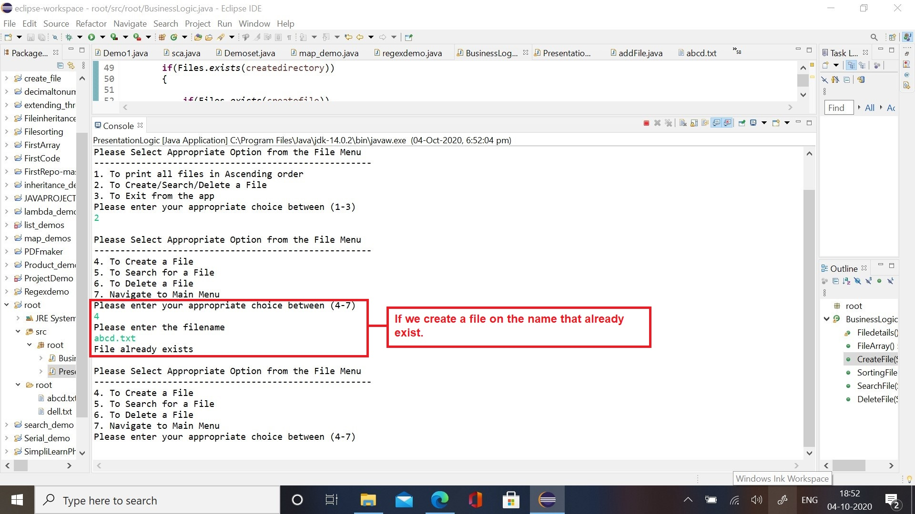

1. Sort File()

This method is used to sort the files in the specified directory. First it loads all the files from the specified directory into the files array and then uses the pre-defined sort method in the arrays to sort those files in ascending order.

a). Arrays.sort(): It is a predefined method which can be used with arrays of any type. Here we sent the type of files as an argument to it.

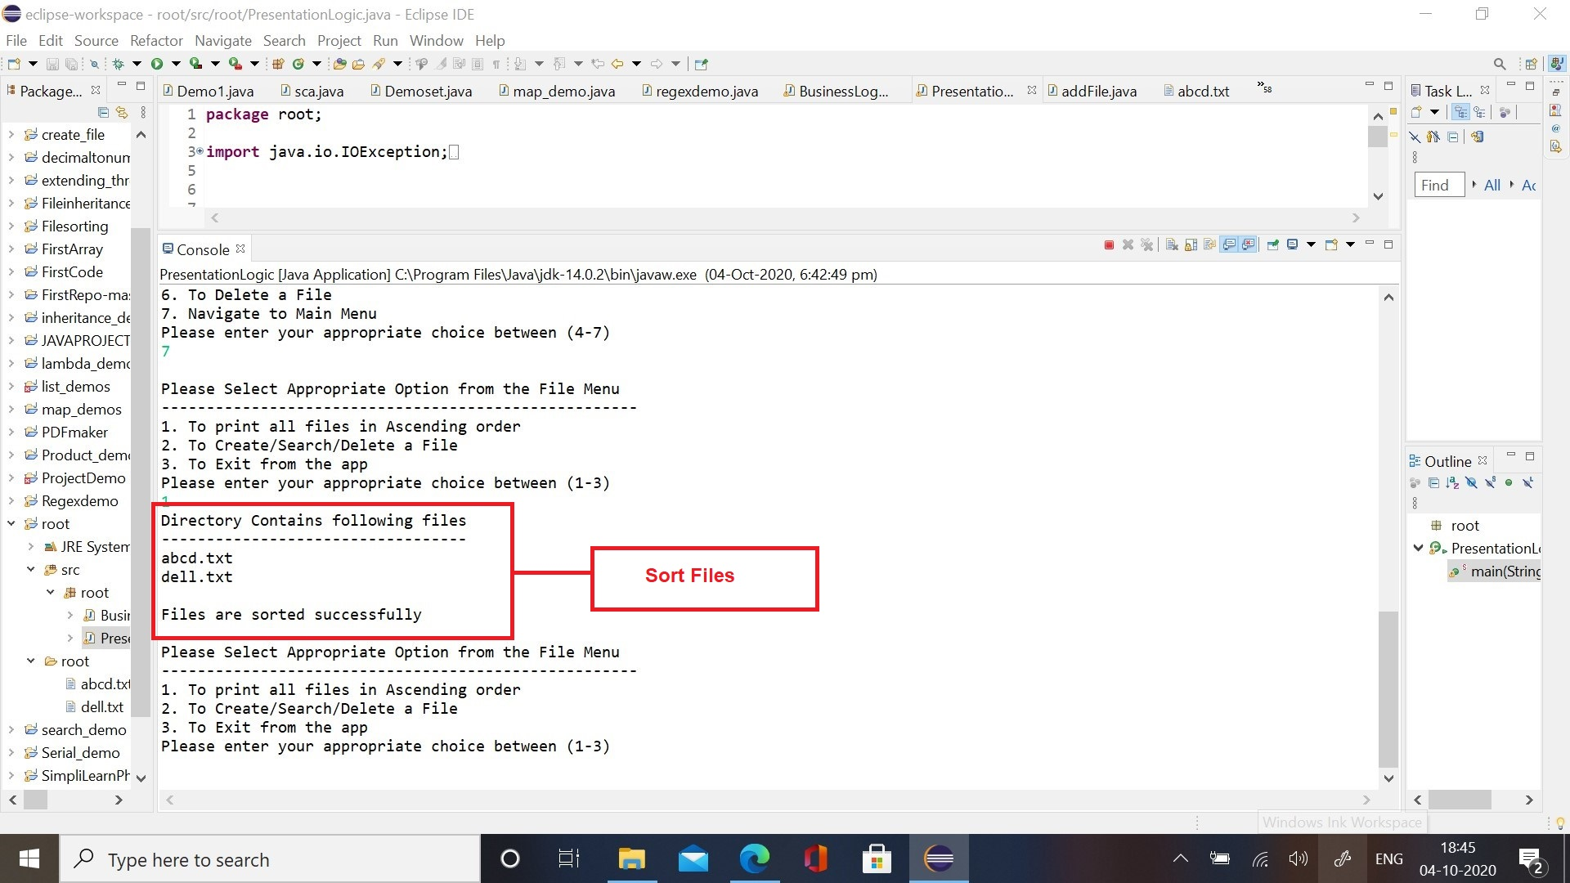

1. Search File()

This method is used to search the files in the specified directory. Here we used the pattern class which is available in java.util.files. Firstly, we create an object for the pattern class and at the same time we send the specified pattern to the constructor of the class, which the files in the directory have to be searched.

1. Pattern.compile() method: This method will filter the files of patterns mentioned as arguments.
2. .matcher() method: This method will search for the pattern which we mentioned in the pattern.compile method in the files array.
3. .find() method: This method will compare the pattern we mentioned with the array of files, if found it returns true and if not found it returns false.

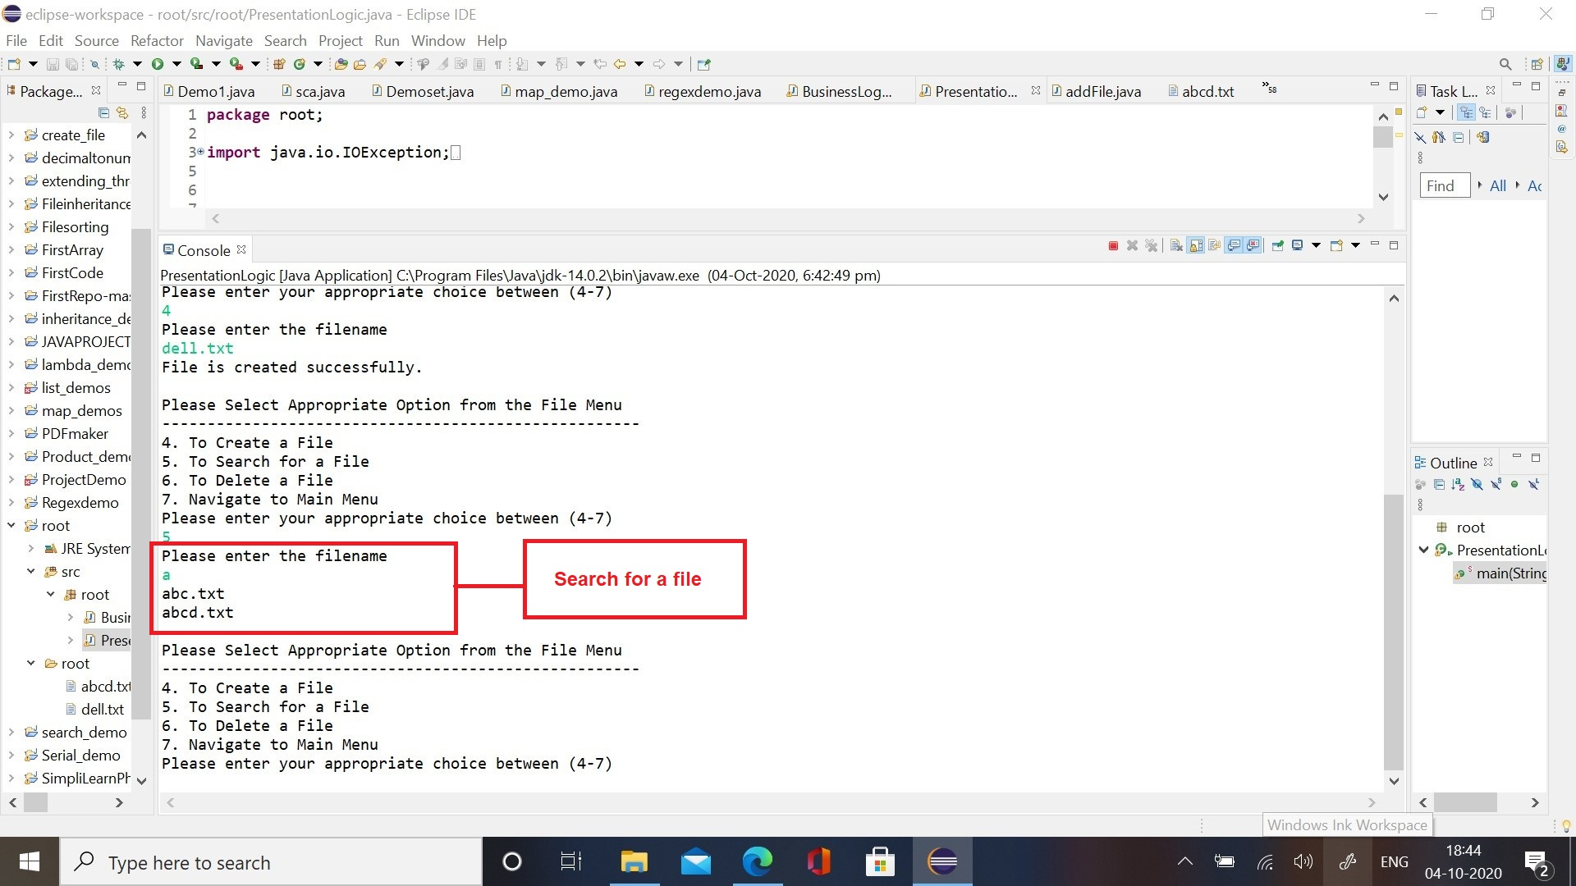

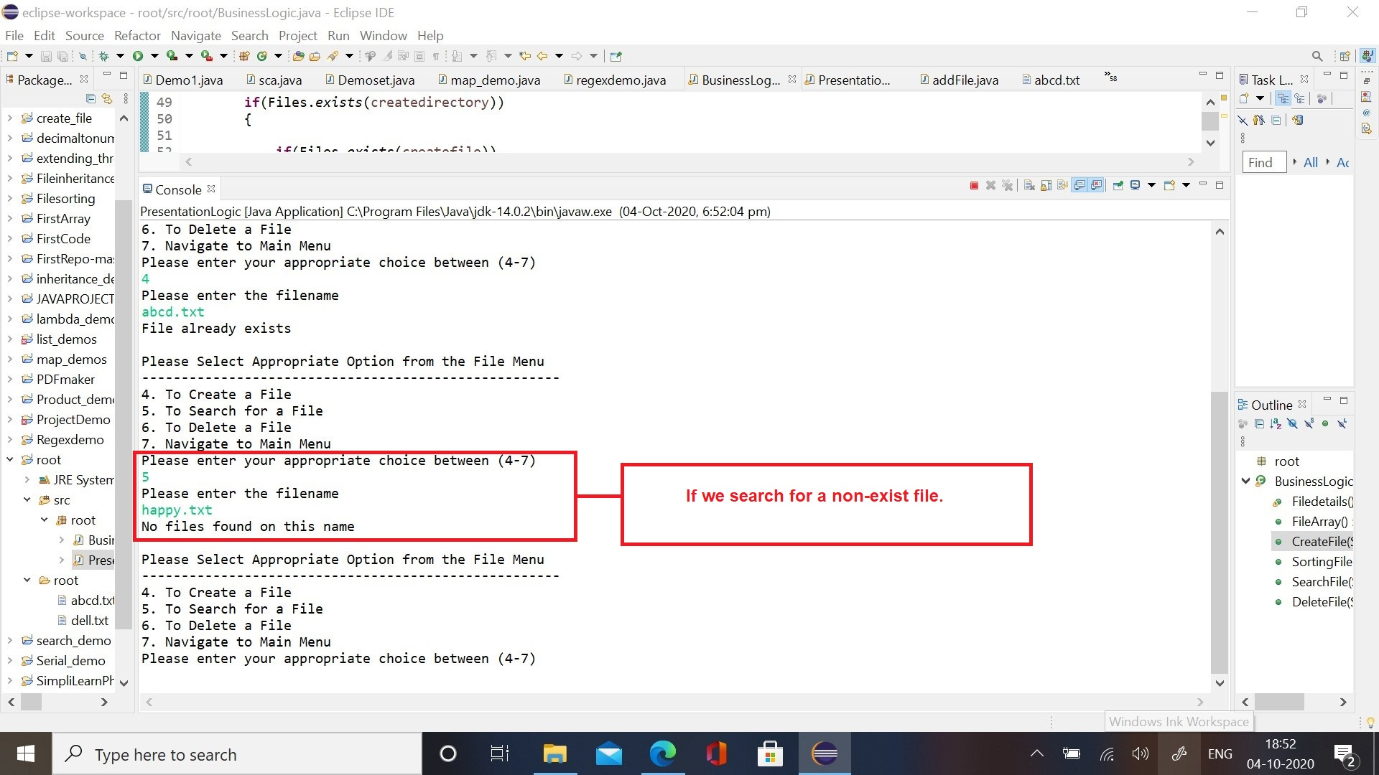

1. Delete File()

This method is used to delete the files in the directory. Here we used the file.delete() boolean method to delete the file. It returns true if file is deleted in the specified directory and returns false if the file is not deleted or does not exist in the directory.

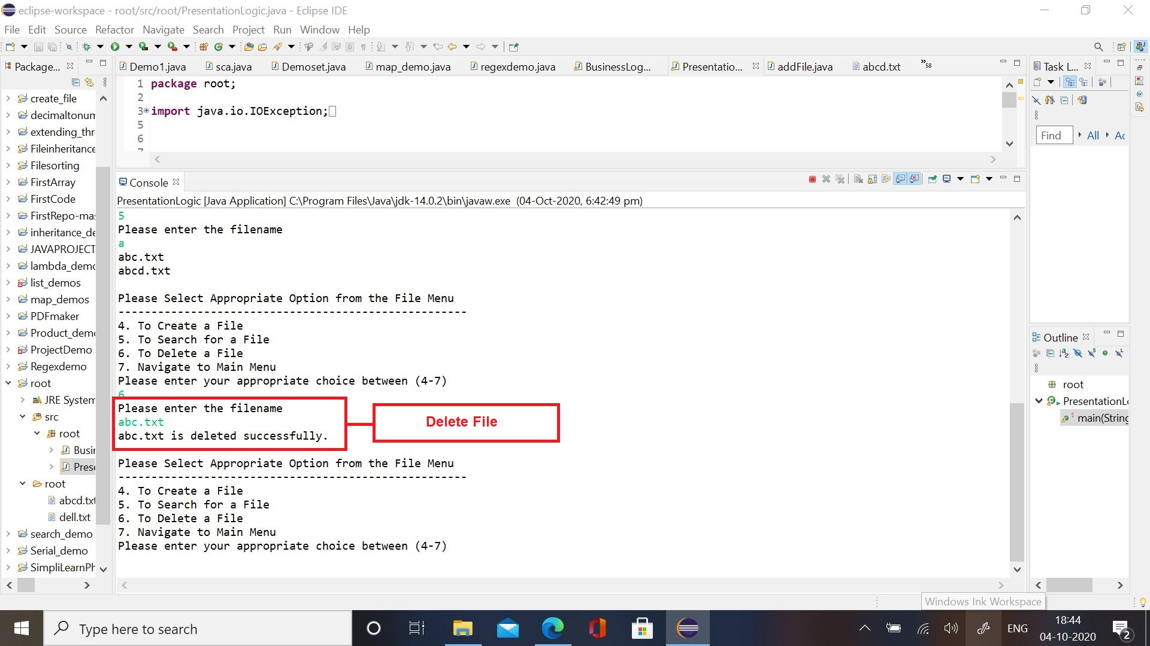

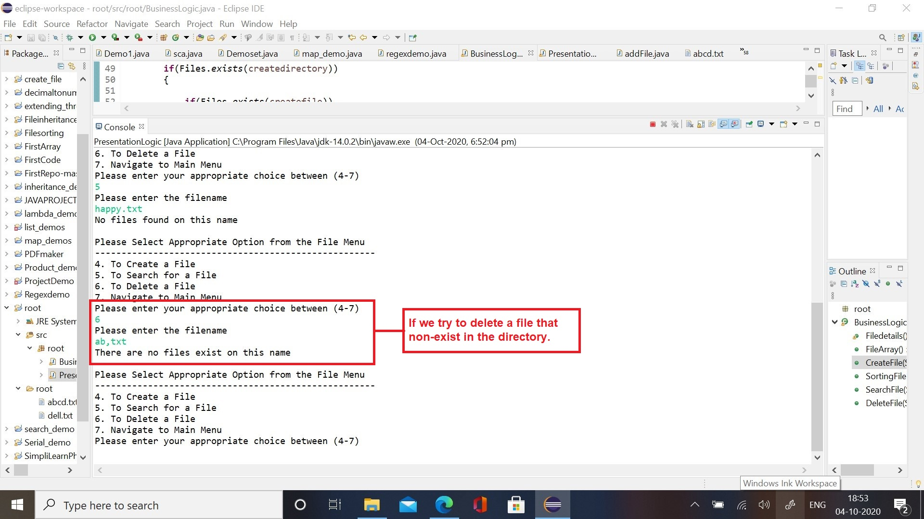

# Tools and Technologies Used:

1. Java concepts used in the application: Classes, Inheritance, Methods, Files and Arrays.
2. Tools Used: Eclipse IDE, Java Programming, GIT, GITHub.

# GIT Source Code Link:

# Conclusion and Unique Selling Proposition:

This application is made of using advanced java programming language, it is bug free and it is a minimum viable product.

It is also made for the user to easily interact with the application.

It is made keeping in the view of the prospective changes, if the product owner wants to add new features to it, it can be done easily.